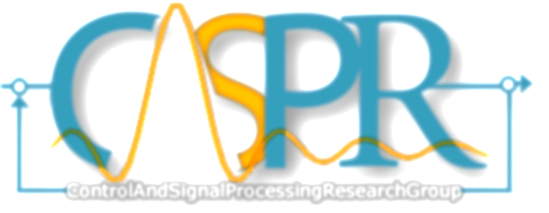
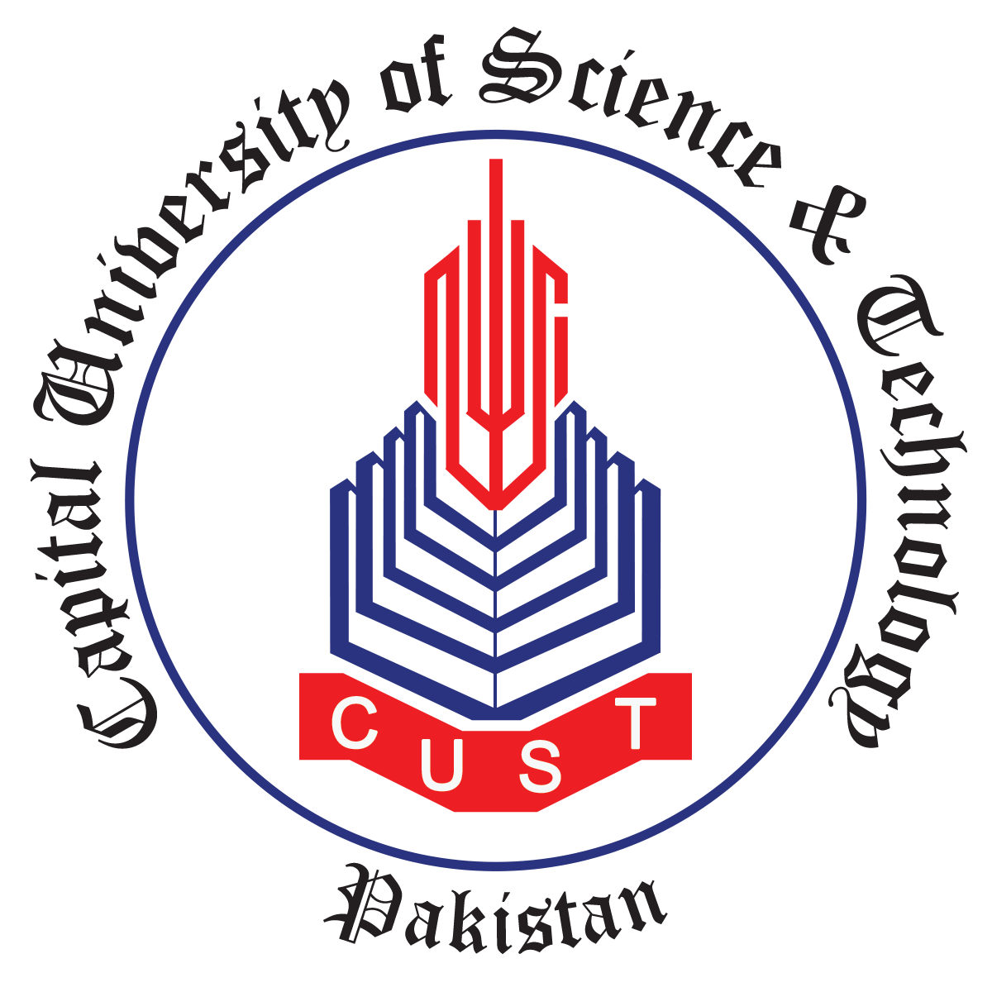
Capital University of Science & Technology, Islamabad

Registration Form for Two Days Workshop on Signal Processing using LabVIEW and Software Defined Radio (SDR)
(30th Nov – 01st December 2020)

Name: ______________________________________________________

Institute/Industry: ______________________________________________________

Department: ______________________________________________________

Designation: ______________________________________________________

Address: ______________________________________________________

Email: ______________________________________________________

Mobile: ______________________________________________________

Signature
Contact Person: Muhammad Raheel Anjum, Assistant Director ORIC, CUST
raheel.anjum@cust.edu.pk 0331-5293054

NOTE: Last Date of Registration is 30th November, 2020
Application Fee: 1,000 PKR

