Career Services Office

Internship Expo - 2023

Internship Expo conducted by the Career Services Office (CSO) with the collaboration of Jinnah management society students on June 06, 2023, Tuesday. The event was an outstanding success, attracting a large number of students from various departments and featuring the participation of over 30 organizations from different sectors.
Objective:
The primary objective of the Internship Expo was to provide students with the opportunity to explore and secure summer internships and job placements. Additionally, it aimed to connect students with potential employers and foster meaningful professional relationships. By hosting this event, our aim was to bridge the gap between academia and industry, ensuring that students have access to real-world experiences and career opportunities.
Planning and Preparation:
The planning and preparation for the Internship Expo started on May 28^{th,} 2023. The Career Services Office and Jinnah Management Society developed a dedicated team to conduct this event. The team was responsible for defining objectives, setting timelines, and assigning responsibilities.
- Identifying Objectives: Career Services Office conducted a comprehensive analysis of internship events. The objectives included increasing student participation, attracting a diverse range of organizations, providing valuable networking opportunities, and facilitating on-the-spot interviews.
- Event Budgeting: A budget was allocated to cover various aspects of the Internship Expo, including venue rental, promotional materials, booth setup, refreshments, and logistics. The team ensured efficient financial management to make the most of the allocated resources.

- Venue Selection: After careful consideration, a suitable venue was selected that could accommodate a large number of participating organizations and students. The venue was centrally located and easily accessible for all stakeholders.
- Contacting Organizations: The Career Services Office reached out to more than 100 organizations from different sectors, inviting them to participate in the Internship Expo.
- The team emphasized the benefits of connecting with potential interns and future talent, highlighting the opportunity to engage with students who possessed diverse skill sets and educational backgrounds.
- Participant Registration: To streamline the registration process, an online platform was developed to allow organizations and students to register for the event. The Career Services Office ensured a user-friendly interface and provided clear instructions for registration.
Event Execution:
The Internship Expo was executed with meticulous planning and attention to detail. Every aspect of the event was carefully coordinated to provide a seamless experience for participants.
- Event Setup: CSO worked closely with the Dy. Director Admin to set up the event space, ensuring that each participating organization had a designated booth area. The booths were strategically arranged to allow easy navigation for students and maximize exposure for the organizations.
- Promotional Activities: A comprehensive marketing campaign was undertaken to promote the Internship Expo. This included email communications, social media campaigns, posters, and announcements on campus through Alumni Office Bearers in each faculty. The office also collaborated with the institution's marketing department to ensure effective promotion.
- On-the-Spot Interviews: Participating organizations conducted on-the-spot interviews with interested students, providing them with the opportunity to showcase their qualifications and skills. Dedicated interview areas were set up to ensure privacy and create a professional atmosphere.
Event Overview:
Date: June 06, 2023
Day: Tuesday
Time: 10:00 AM to 4:00 PM

Participating Organizations:
A total of 30 organizations, representing diverse sectors, actively participated in the Internship Expo. The organizations included renowned companies, non-profit organizations, and a few international ones. Their presence provided a wide range of opportunities for students to explore and consider. The sectors represented included finance, technology, healthcare, engineering, marketing, education, etc.
Organization Name | Focal Person
ibex. Pakistan | Hoorain Ashraf
Turnotech Pvt Ltd | Muneeb uz Zaman
Lads Technologies | Usama Zahid
Tangent Technologies | Mohsin Jamal
Synergy-IT | Zoha Khalid
Islamabad Diagnostic Centre (Pvt) Ltd | Mamoona Sarwar
Beta Angel's | Ms. Faiza Dar
Funsol Technologies | Muhammad Jazib
Excel Labs (Pvt)Ltd | Mukarram
Trillium Information Security System | Arooj Aftab
Lolc Microfinance Bank | Muhammad Jehanzeb Shaheen
The IEIS Education Group LTD | Kinza Martin
Mobify | Hamza Ahmed
Helping Hand for Relief and Development | Zaid Ali
Army Welfare Trust | Sidra Saleem
Climaxcode Technology | Shehla Kayani
HUAWEI TECHNOLOGIES | Nimra Pervaiz
ICrowdNewswire | Aqib Kafayat
Green Lambda | Ayesha Khan
Nayatel | Syed Kumail Abbas
TeleTaleem Pvt Ltd | Aliya Naseeb
Markalytics | Mariyam Iftikhar
Evolution Pharmaceuticals Pvt Ltd | Akhter Hussain
Chughtai Health Care | Asma wasti
Medxol Healthcare Management Company | Hasan Iqbal
Next-gen marketing | Wasia
MASON1 | Sehrish Afshan
Zahid Latif Khan Securities pvt ltd | M. Hamza Anwaar
Creative Garage Pvt. Ltd | Saba Sohail
Floret Commodities (Pvt.) Ltd. | Talha Naveed
Student Participation:
Students from all departments of our institution enthusiastically participated in the event. The Expo attracted a diverse group of students, including undergraduates and graduates, from various disciplines. The event provided them with a platform to showcase their skills, knowledge, and passion, and to interact directly with potential employers. The department-wise registration details are as under;
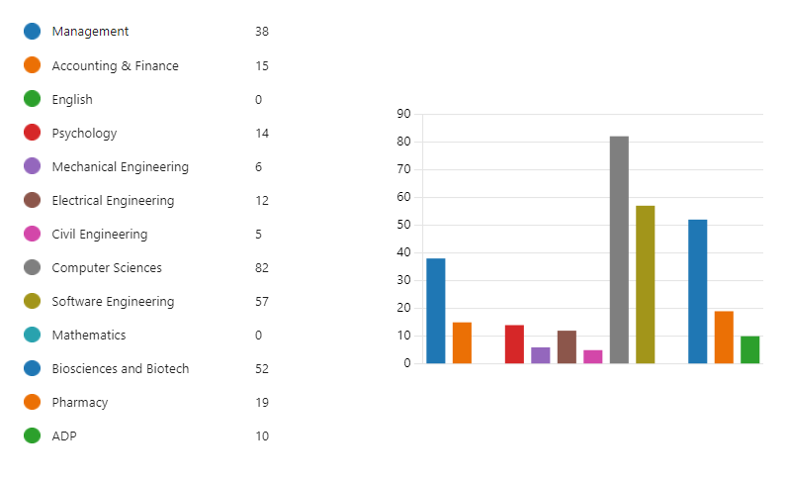
Note: A total of 639 students participated in the internship expo
The Internship Expo was not limited to graduating students or those near graduation. Junior students, ranging from 1 to 4th semester, also actively participated in the event with the intention of gaining valuable learning experiences and exploring potential internship opportunities.

Career Services Office made sure to emphasize that the Internship Expo was open to students of all levels, as internships can provide valuable insights and practical knowledge to help them shape their career paths.
Junior students, in particular, found the Internship Expo to be a great platform for learning about the professional world and gaining exposure to various industries. By engaging with organizations and attending informational sessions, they had the opportunity to understand the requirements and expectations of internships in their fields of interest. The expo provided them with a chance to network with industry professionals and seek guidance on career development from experienced individuals.
Furthermore, participating organizations were briefed about the presence of junior students and were encouraged to engage with them by providing insights, advice, and potential learning opportunities. The Career Services Office also facilitated mentorship programs where junior students could connect with professionals in their areas of interest to seek guidance and support.
The inclusion of junior students in the Internship Expo was an integral part of our efforts to foster a holistic approach to career development. By offering opportunities for learning and exposure at an early stage, we aimed to empower students to make informed decisions about their academic and professional journeys.
Activities and Offerings:
- Booths and Displays: Each participating organization had a dedicated booth to present its company's information, culture, and internship/job opportunities. The booths were creatively designed and thoughtfully arranged to create an engaging environment for students. Organizations displayed their promotional materials, brochures, and company swag to attract the attention of students.
- Interview Sessions: Organizations conducted on-the-spot interviews with interested students, providing them with the chance to showcase their qualifications and skills. These interviews were a key element of the Expo, as they allowed students to make a lasting impression and potentially secure internships or job placements. Interview areas

were strategically placed within the venue to ensure privacy and facilitate smooth conversations.
- Networking Opportunities: The Expo facilitated networking opportunities for both students and employers where students could engage in meaningful conversations with
industry professionals, gain industry-specific advice, and expand their professional network. Students were encouraged to exchange contact information, share their resumes, and establish connections for potential future opportunities.
- Outcome and Feedback:
The Internship Expo received overwhelmingly positive feedback from both students and participating organizations. Several students were able to secure internship offers and job placements through on-the-spot interviews. Participating organizations expressed satisfaction with the quality of candidates they interacted with and commended the proactive nature of the students.
Recommendations
- Early Promotion: In future events, we will ensure that the announcement and advertisement of the Internship Expo are initiated at least 3 weeks earlier. This will allow for better publicity among students and faculty, attracting a larger pool of participants.
- Expanded Industry Representation: While the current Expo featured a diverse range of sectors, we aim to further expand the industry representation in future events. This will provide students with a broader spectrum of opportunities and enhance their career exploration.

Conclusion:
The Internship Expo conducted by the Career Services Office on June 06, 2023, was a highly successful event. The participation of more than 30 organizations from different sectors and the active involvement of students from all departments contributed to its success. We are pleased to have provided a platform that facilitated connections between students and potential employers, resulting in internships and job placements for many.
We express our gratitude to all the organizations, students, and staff members who contributed to the success of the Internship Expo. We remain committed to organizing similar events in the future, continuously striving to provide students with valuable opportunities to launch.
