NextGen Corporate Summit 2023
A Comprehensive Report on Academic-Industry Convergence
Title: NextGen Corporate Summit 2023
Theme: Navigating transition from Campus to Corporate
Date: December 28, 2023
Day: Thursday
Time: 09:00Am – 5:00 Pm
Organizer: Career Services Office CUST Islamabad
Students of Following Departments Participated: More than 1500 students participated
- Faculty of Pharmacy
- Department of Health and Life Sciences
- Department of Management
- Department of English
- Department of Psychology,
- Department of Accounting and Finance
- Department of computer sciences
- Department of Ssoftware engineering
- Department of Civil Engineering
- Department of Eelectrical Engineering
- Department of Mmechanical Engineering
The NextGen Corporate Summit 2023 was a resounding success, bringing together academia and industry in a dynamic exchange of ideas and opportunities. The summit comprised five major events, each contributing to the overarching goal of enhancing collaboration between students, faculty, and corporate entities.
- A major highlight of the event was the series of interviews conducted by 60 prominent companies. These interviews targeted students from the 8th, 7th, and 6th semesters, providing them with valuable opportunities for hiring and placement. Notably, participants from all semesters and departments were encouraged to engage, fostering maximum industry interaction.
- Projects Review: Students presented their projects to experts from Python Leads Private Limited, ZiCon International, Adventures Private Limited, National Incubation Centre Aerospace and Technology, and Shaigan Pharmaceutical Pvt Ltd. This provided a platform for constructive feedback and facilitated valuable industry-academia interaction.
- Panel Talks: Three engaging panel discussions, featuring seasoned professionals, explored the theme of transitioning from campus to corporate life. These talks delved into market insights, skill demands, and adapting to change, offering students invaluable insights for a smooth transition.
- MoU Signings: Strategic Memorandums of Understanding were signed with five organizations—Aspire Institute, National Incubation Centre of Aerospace and Technology, Gubloo Private Limited, Nayatel Private Limited, and Synergy IT. The MoUs aimed at fostering collaboration in students' placement, research, and faculty development, effectively bridging the gap between academia and industry.
- Iconic Projects Display: The summit showcased departments' iconic projects, providing a tangible representation of CUST's academic prowess. This not only celebrated students' achievements but also facilitated networking opportunities and industry recognition.
NextGen Corporate Summit 2023 successfully blended academic depth with corporate engagement. By facilitating projects review, panel discussions, MoU signings, a career expo, and a showcase of iconic projects, the summit not only enriched the learning experience for students but also strengthened the collaboration between academia and industry. The event was a testament to CUST's commitment to producing well-rounded, innovative graduates poised for success in the corporate world

INTERVIEWS
Career Services Office successfully organized the NextGen Corporate Summit 2023 on December 28th, Thursday, at Capital University of Science and Technology. The summit aimed to bridge the gap between students and the corporate world, offering a unique platform for career development.
A major highlight of the event was the series of interviews conducted by 60 prominent companies. These interviews targeted students from the 8th, 7th, and 6th semesters, providing them with valuable opportunities for hiring and placement. Notably, 582 participants from all semesters and departments got industry interaction.
Job Opportunities:
The summit played a pivotal role in early career development, allowing students to secure job offers even before graduation. A total of 60 organizations participated, conducting interviews for over 1100 vacant positions. The diversity of opportunities extended across various sectors, including 11 from the Banking Sector, 35 from IT, 5 from Engineering, and 5 from Pharmaceutical and Biolabs. This strategic selection aimed to cater to students from all departments. Sector wise classification of organizations.
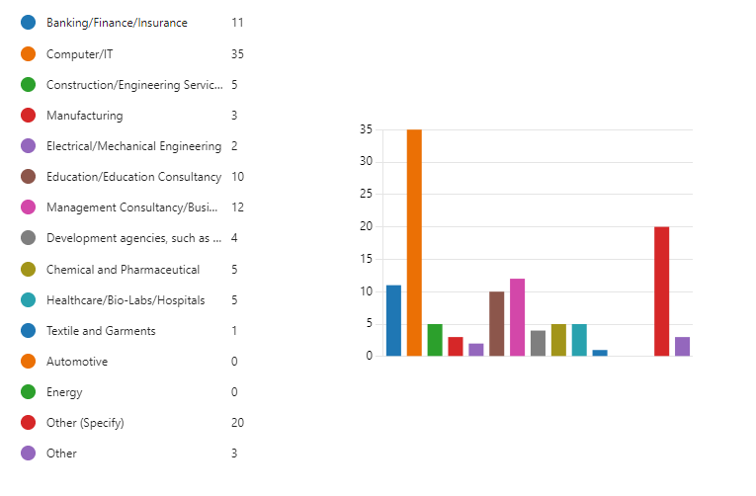
Industry Engagement:
The NextGen Corporate Summit served as a hub for industry interaction, facilitating meaningful connections between students and reputable organizations. The broad representation of companies from different sectors ensured a comprehensive range of career paths for the attending students.
Departmental Engagement:
The Career Services Office effectively categorized students into three primary groups based on their career aspirations. Firstly, for those seeking employment, companies were specifically invited for hiring purposes. Secondly, for aspiring entrepreneurs, Incubation Centres were present to provide guidance and support. Lastly, for students interested in foreign education, education consultants were invited, emphasizing a holistic approach to career development. The registered organizations show interest to interact with the following department students.
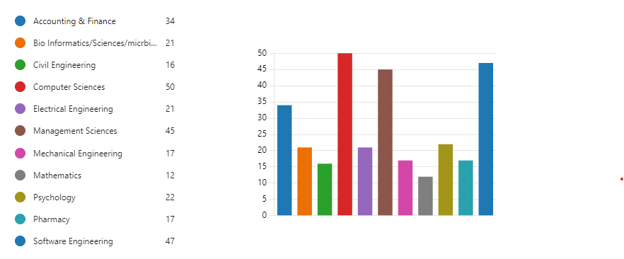

The success of the NextGen Corporate Summit 2023 underscores the commitment of the Career Services Office in facilitating diverse and impactful career opportunities for students. The event not only provided a platform for job placement but also embraced the broader spectrum of students' career aspirations, making it a well-rounded and beneficial experience for all participants.

PROJECTS REVIEW
The second major event of the NextGen Corporate Summit 2023 witnessed a comprehensive Projects Review, where students from various departments showcased their innovative projects. The review process took place from 10 AM to 4 PM and involved expert evaluations from prominent organizations. The participating organizations included:
Python Leads Private Limited: This organization contributed insights into projects that utilized artificial intelligence. Their feedback likely focused on technical proficiency, coding standards, and the practical application of in real-world scenarios.
- ZiCon International (Headquartered in Dubai): As an international entity, ZiCon International brought a global perspective to the review process. Their evaluation criteria may have encompassed aspects like scalability, adaptability to diverse markets, and adherence to international standards.
- Adventures Private Limited: With a name suggestive of dynamism and creativity, Adventures Private Limited likely emphasized innovation, user experience, and the potential for projects to disrupt or bring about positive change in the industry. It incubates different projects for fund raising and financing.
- National Incubation Centre Aerospace and Technology: As a centre focused on aerospace and technology incubation, their evaluation likely cantered on projects' alignment with industry trends, technological advancements, and potential contributions to the aerospace sector.

- Shaigan Pharmaceutical Pvt Ltd: This pharmaceutical entity would have assessed projects related to healthcare, pharmaceuticals, and bioinformatics. Their feedback likely concentrated on the projects' impact on healthcare, adherence to regulatory standards, and potential advancements in pharmaceutical research.
During the review, the organizations' experts provided detailed feedback on each project, considering various aspects such as technical proficiency, innovation, feasibility, and alignment with industry needs. The jury, consisting of professionals from these organizations, communicated their evaluations to the respective faculty members overseeing the projects.
This Projects Review served as a crucial platform for students to receive constructive criticism, valuable insights, and recognition for their hard work. It also facilitated meaningful interactions between academia and industry professionals, fostering an environment of collaboration and knowledge exchange. Overall, the event played a pivotal role in bridging the gap between theoretical learning and practical application in the corporate world.

PANEL TALKS
The third major activity of the NextGen Corporate Summit 2023 comprised a series of insightful Panel Talks, bringing together 410 students from various departments. Each session extended over 90 minutes, and three distinctive panels were conducted, all centred around the theme "Navigating the transition from Campus to corporate."
Panel Talk 1:
Panellists:
- Mr. Parvez Abbasi (GM, Umar Farooq Nayatel)
- GM Operations Pharmaceutical (Unspecified Name)
- Convened by: Ms. Rabia Habib (Faculty member, Department of Management Sciences)
- Theme: Navigating the transition from Campus to corporate.
The inaugural panel delved into crucial aspects of transitioning from academic settings to the corporate world. Market insights, skills in demand, and the ability to adapt to change were central topics. Ms. Rabia Habib was the convener of the talk. The panellist provided valuable insights on how students can smoothly navigate this transition.
Panel Talk 2:
panellists:
- Mr. Khurram Ali Khan (COO, ASK Development)
- Dr. Shahid Naeem (Economist and Government Advisor)
- Muhammad Ahsan Ullah (Manager HR Analytics)
- Theme: Navigating the transition from Campus to corporate.
The second panel echoed the theme of the first, emphasizing the importance of a seamless transition. The panellists, including industry veterans and an HR Analytics manager, offered diverse perspectives on market readiness and the skills essential for success in the corporate sphere.
Panel Talk 3:
- Panelists: Mr. Parvez Abbasi
- Location: FM Studio Room
- Theme: Navigating the transition from Campus to corporate.
The unique setting of an FM Studio Room added an interesting dimension to the third panel talk with Mr. Parvez Abbasi. While the setting varied, the overarching theme remained consistent — preparing students for a successful transition into the corporate world.
All three panel talks shared a common objective: guiding students on the preparedness required for the corporate market. They collectively underscored the significance of adaptability, understanding market dynamics, and acquiring the skills demanded by the industry. These sessions not only enriched the students' knowledge but also fostered a platform for direct interaction with seasoned professionals, facilitating a bridge between academic knowledge and practical corporate insights. The NextGen Corporate Summit 2023's Panel Talks proved instrumental in shaping the perspectives of aspiring professionals, paving the way for a more informed and prepared workforce.
MOU SIGNING CEREMONY
The fourth major event during the NextGen Corporate Summit 2023 was a significant milestone as the summit facilitated Memorandum of Understanding (MoU) signings with five prominent organizations. The purpose of these MoUs was to foster collaboration in various key areas, including students' placement, research collaboration, and faculty development programs. The organizations involved in this strategic partnership were:
- Aspire Institute, USA
- National Incubation Centre of Aerospace and Technology
- Gubloo Private Limited
- Nayatel Private Limited
- Synergy IT Private Limited
The primary objective of these MoUs was to bridge the gap between academia and industry. By formalizing partnerships with these organizations, the summit aimed to create avenues for students to seamlessly transition from academic settings to the professional world. The collaborative efforts were expected to enhance research opportunities, provide valuable industry exposure, and contribute to the overall development of faculty members.
This Expo served as a dynamic platform for departments to engage in meaningful interactions with the participating organizations. These interactions were designed to explore potential collaborations for the betterment of academic departments across various crucial areas, including:
- Placement: Facilitating job placements for students by connecting them with prospective employers, thereby aligning academic learning with industry requirements.
- Students Development: Creating opportunities for students to engage in internships, workshops, and training programs, enhancing their practical skills and industry relevance.
- Faculty Development: Establishing programs and initiatives that would contribute to the continuous professional development of faculty members, ensuring they stay abreast of industry trends and advancements.
- Research Collaboration: Fostering partnerships that encourage joint research initiatives, enabling the exchange of knowledge and resources between academia and industry.
The Expo provided a valuable space for departments to initiate discussions, negotiate partnerships, and form collaborative strategies with the participating organizations. This initiative was instrumental in strengthening the link between academic institutions and industry players, paving the way for mutually beneficial relationships.
In summary, the MoU signings and Career Expo at the NextGen Corporate Summit 2023 exemplified a commitment to narrowing the gap between academia and industry. These strategic partnerships were aimed at creating a holistic learning environment for students, facilitating faculty development, and fostering research collaborations that contribute to the advancement of both academia and industry.

SHOWCASE OF ICONIC DEPARTMENTAL PROJECTS
The fifth major event during the NextGen Corporate Summit 2023 was a captivating showcase that highlighted the academic prowess and depth of the Capital University of Science and Technology (CUST). This event involved the display of departments' iconic projects, serving as a visual testament to the institution's academic excellence.
Event Overview:
- Objective: To exhibit the academic width and depth of CUST through the presentation of iconic projects from various departments.
- Participating Departments: All academic departments of CUST.
- Duration: The display spanned throughout the summit.
Highlights:
- Diversity of Projects: The showcased projects represented a diverse array of academic disciplines, illustrating the comprehensive academic curriculum at CUST. This diversity ranged from engineering innovations to business strategies, showcasing the university's commitment to multidisciplinary education.
- Innovation and Creativity: The projects on display exemplified a high degree of innovation and creativity. From technological advancements to entrepreneurial endeavours, the exhibition demonstrated the ability of CUST students to think critically and contribute to cutting-edge solutions.

- Interactive Displays: Rather than a passive exhibit, the event encouraged interactive displays. Attendees had the opportunity to engage with project creators, fostering a dynamic exchange of ideas and insights. This interactive format enhanced the learning experience for both students and industry professionals.
- Networking Opportunities: The display provided a platform for students to connect with industry experts and potential employers. This facilitated networking and opened avenues for collaboration, internships, and future employment opportunities for the talented pool of CUST students.
Impact:
- Showcasing Academic Excellence: The event effectively showcased the academic excellence of CUST by presenting tangible outcomes of students' hard work, creativity, and academic rigor.
- Industry Recognition: The display of iconic projects garnered recognition from industry professionals, reinforcing the university's reputation for producing skilled and innovative graduates.
- Inspiration for Future Students: The showcase served as an inspiration for current and prospective students, highlighting the caliber of projects achievable at CUST and motivating them to strive for academic excellence.

The success of the NextGen Corporate Summit 2023 underscores the commitment of the Career Services Office in facilitating diverse and impactful career opportunities for students. The event not only provided a platform for job placement but also embraced the broader spectrum of students' career aspirations, making it a well-rounded and beneficial experience for all participants.

NextGen Corporate Summit 2023
HIGHLIGHTS
